About us page

CORE inc. is a company that provides value to corporations and individuals

CORE inc. has four distinct operations:

- CORE inc. – Management Consulting specializing in project management and project rescues.
- JIWA Financials – is a fully integrated, Microsoft Windows and Microsoft SQL Server solution containing all the ledgers and functions expected of modern accounting systems, with powerful inventory-centric features that provide Importers, Distributors, Manufacturers, Service/Repairers and companies needing comprehensive reporting with better control over their operations and with time-saving workflows throughout all their business cycles.
- CORE Financial Service – Wealth Creation Company that achieves wealth by adding value to your portfolio because of our differentiation in our business model, wealth of experience and our commitment to our investor’s success.
- CORE Venture – Markets and develops business solutions to meet today’s business needs.

CORE Inc. Home page

CORE Inc. is a management consulting firm specializing in program management, project management, project rescues, business reengineering, and support organizations. Our core competencies are the ability to successfully manage/rescue enterprise business solution projects by focusing on the business value of an implementation and further drive out measurable value by establishing a unique support organization for a rapid return on investment.

The difference between CORE Inc. and other firms can be found in many areas including our operating philosophy and structure, our resources and skills, our networks, our affiliations and the clients we serve. We are committed to guiding principles that include standards for service, integrity and adding value. We are more than just management consultants, we help our clients examine the way they do business, focus on key success factors and effect change within the business that improves shareholder value.

We're approachable; we listen and ask the right questions.

Success page

CORE Inc. and SAP

CORE and SAP have combined comprehensive business knowledge, technical wisdom and implementation experience to provide world-class solutions. By focusing on the business value of an implementation, we work together to provide solutions that can improve your bottom line through helping to reduce costs and increase revenue.

Our successes are listed below. For references, please contact CORE

Agrium Inc., Calgary, Alberta  AltaLink, Calgary, Alberta  AnTelcom, Curacao, Netherlands Antilles  Aquila Networks Canada, Calgary, Alberta  Bauer Nike Hockey, Greenland, New Hampshire  BC-TEL, Vancouver, British Colombia  Connexim, Montreal, Quebec | Ericsson Canada, Toronto, Ontario  Peerless Clothing, Montreal, Quebec  SAP AG, Walldorf, Germany  Suncor, Calgary, Alberta  Telus Corporation, Edmonton, Alberta  TransAlta, Calgary, Alberta  West Coast Energy, Vancouver, British Colombia  Zurich Financial Services, Zurich, Switzerland

Service page

Driving Projects

It's about having the determination, dedication, and energy to give it your all, propel your projects forward, and achieve new success. Like you, we understand the power of potential and imagination to ignite the biggest opportunities. Our services, our people, our products and our passion can fuel that kind of projects - to take your business further, faster.

CORE services are designed to help you meet the challenges of managing risk, projects, resources and information. Our experienced, knowledgeable consultants work with you to help you understand what the risks are and how to face them. We use the latest technological tools to provide customized services and advice tailored to the nature and circumstances of your business.

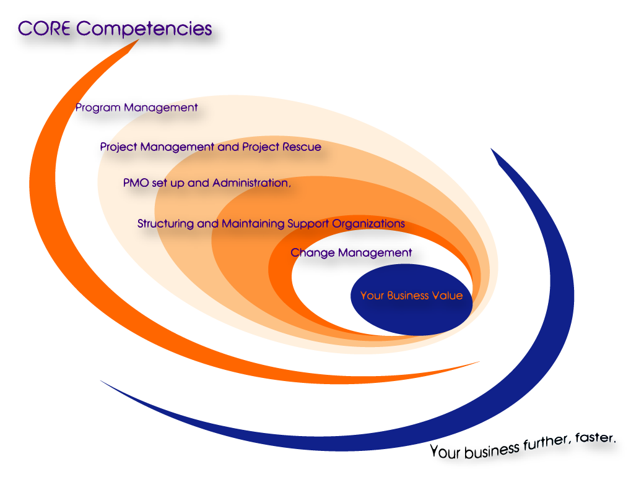

Services include

Professional program management, project management, project rescues, PMO set up and administration, business case and strategy definition, functional and business requirements, technology assessment and gap analysis, business process evaluation, change management, implementation and rollout planning, test plan development, user acceptance plans, and structuring and maintaining support organizations.

Career

At CORE we truly are different than the rest. We put people ahead of numbers, professionalism before profit. We're good at making work fun and committed to getting even better. Our clients look to us for professional advice on diverse issues, not just Management consulting services.

At CORE, it's our business to help our clients succeed. It's exciting work – and a lot more than high level “pie in the sky” statements. It means getting out from behind the desk and learning about their business inside and out. It means staying on top of what's happening in their industry, what's new in technology, what regulatory changes mean to them and much more. It's building a relationship, one-on-one over time, to become their preferred adviser.

If you feel that you might have something to offer and want to become a key player on a winning team, please feel free to send your resume to us! Email your credentials in MS Word or PDF format to resume@coreinc.ca. Please note that only those parties in whom we are interested will be contacted.

JIWA Financials

Take Control

JIWA Financials will help your company draw information from many diverse sources into one recognisable and controllable information system.

JIWA Financials will help your company build and grow new markets and capitalise on your evolving business opportunities - whilst you stay in control. You can increase your customer service level and profitability while also controlling costs, controlling inventory and improving your ability to manage the business.

Organisations depend on JIWA Financials to enhance their business processes and improve their operations. JIWA Financials provides solutions that scale from single users to international enterprises in many industry sectors. JIWA Financials addresses business challenges for a wide range of industries including; Financial Services, Information Technology, Warehousing, Systems Integrators, Importers, Distributors, Service companies, e-procurement, Manufacturing, and General Utilities.

JIWA Financials is a fully integrated financial management solution that enables users to leverage the power of superior technology, through a dynamic range of features and functionality, delivering the control and productivity improvement needed to meet today’s critical business requirements.
JIWA Financials provides a robust and reliable platform enabling customers to handle the exponential growth of today’s growing companies, allowing businesses to grow revenues, strengthen customer relationships and expand distribution channels to gain a competitive edge.

With JIWA Financials, organisations can deliver information and services to customers precisely the way they want, by taking advantage of the comprehensive and flexible capabilities in the system and by leveraging the power of JIWA Financials.

The company’s products, combined with its world-class professional services and partner technologies, provide a comprehensive platform for integrated solutions.

Wealth Creation

CORE Financial Services is a story of security, value and growth. Our referral based growth has been the result of providing attractive opportunities, typical not available to individuals, to investors like you, and consistently selecting investment areas and properties that have performed.

CORE Financial Services is unlike anything in North America today. CORE Financial Services has created a virtually hassle-free approach to Real Estate investing, and helped our clients acquire real estate, on title, that they own.

Our mandate is to create financial freedom for our clients through well-selected real estate investments. Our Mission:

Security: All properties offered for investment will undergo rigorous due diligence.

Value: Every investment property is priced to perform and give the best possible value.

Growth: Our clients are presented with quality investments in markets that offer the best growth potential.

Our partners seek investment opportunities according to stringent and consistent criteria. These include local market conditions, the quality and positioning of an individual project within that market, the opportunity to acquire on favourable terms, the development potential and the long-term appreciation outlook. Our partners maintain and utilize extensive network of complementary relationships and alliances, including North American real estate industry leaders and legal, financial, and investment experts. Through these core strengths we are able to offer a significant value proposition to first-time and repeat investors: research benefits, time-sensitive project acquisition, portfolio diversification, and cash-positive investments.

We feel we can assist you in achieving wealth by adding value to your portfolio because of our differentiation in our product offering, specifically,

Our products have achieved average annualized returns of 18%

Our investors have never lost money.

Our investors have a 100% principal buy-back option on their investment.

To learn more about our product offering contact CORE Financial Services.

